**John Martin 1789 -1854**

In comparison to the sketches In Transformations of nature which L. da Vinci has done. Or the Illustrated coloured lithographic plates and wood cuts by Barnard. G, a series of “Progressive instructions in sketching” like “*the great day of his wrath” 1851-3*…

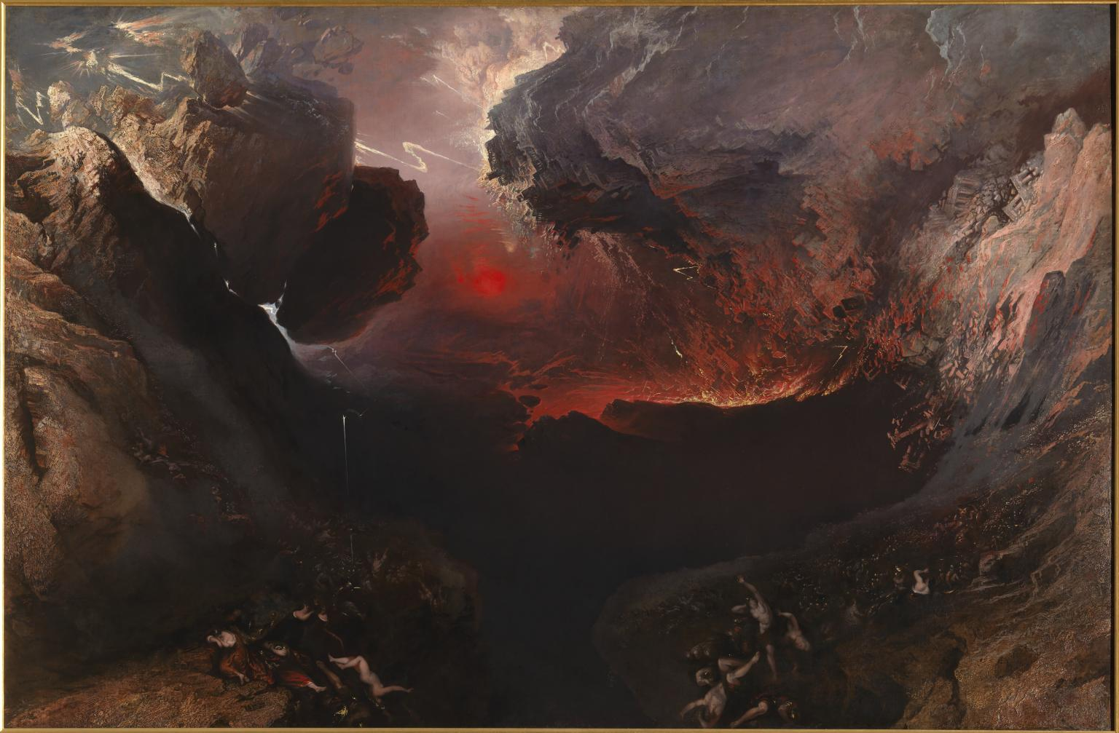

And the versatility of ‘Utopia vs Dystopia’, provides a double-edged sword in Martin’s work, which is shown through “*The plains of heaven*”,

